**《Fundamentals of Electric Circuits》homework 6**

**7.7 Assuming that the switch in Fig. 7.87 has been in position A for a long time and is moved to position B at *t = 0*,Then at *t = 1* second, the switch moves from B to C. Find *vC(t)*for *t≥0*.** (10’)

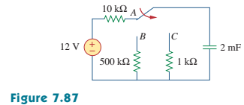

**7.16 Determine the time constant for each of the circuits in Fig. 7.96.** (10’)

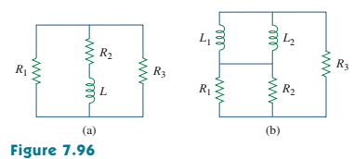

**7.19 In the circuit of Fig. 7.99, find *i(t)* for *t > 1* if *i(0) = 6 A*.** (10’)

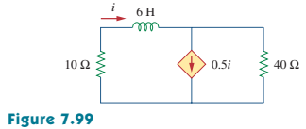

**7.29 Sketch the following functions:**

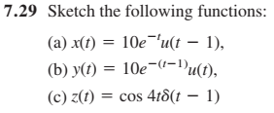(10’)

**7.37 A circuit is described by**

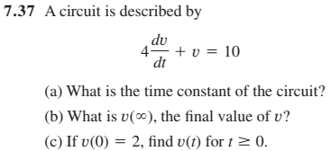(10’)

**7.43 Consider the circuit in Fig. 7.110. Find *i(t)* for *t < 0* and *t > 0*.** (10’)

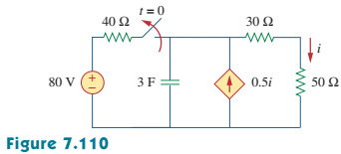

**7.54 Obtain the inductor current for both *t < 0* and *t > 0* in each of the circuits in Fig. 7.120.** (15’)

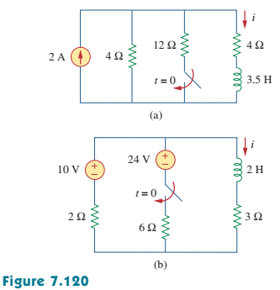

**7.57 Find *i1(t)* and *i2(t)* for *t > 0* in the circuit of Fig. 7.123.** (10’)

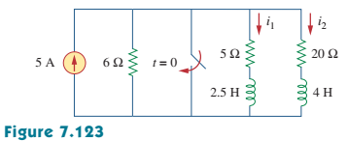

**7.85 A simple relaxation oscillator circuit is shown in Fig. 7.145. The neon lamp fires when its voltage reaches *75 V* and turns off when its voltage drops to *30 V*. Its resistance is *120Ω* when on and infinitely high when off.**

**(a) For how long is the lamp on each time the capacitor discharges?**

**(b) What is the time interval between light flashes?** (15’)

